1. 总结 2

2. 第一次 2

3. 第二次 41

4. 第三次 41

# 总结

在VMWare Player 6.0 上安装Ubuntu 64 位的server版

一共装了三次，前两次都失败了，最后一次成功。

原因可能是第三次选择安装所有的drivers， 而不是仅仅针对target system

# 第一次

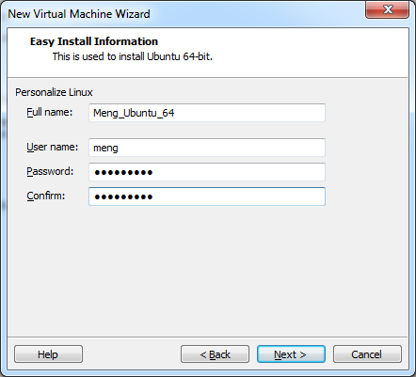

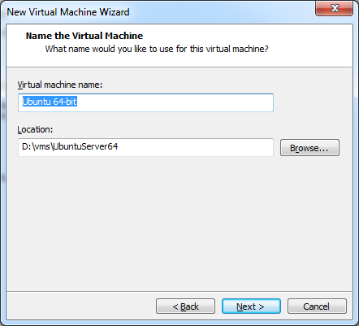

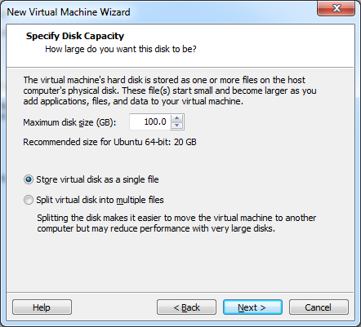

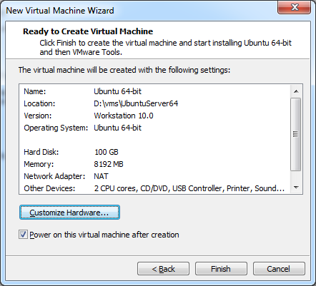

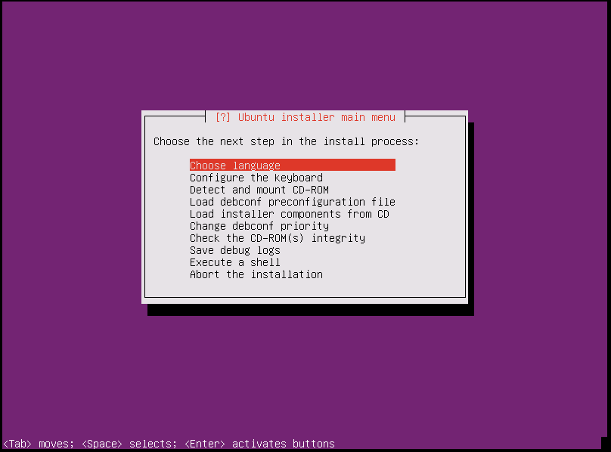

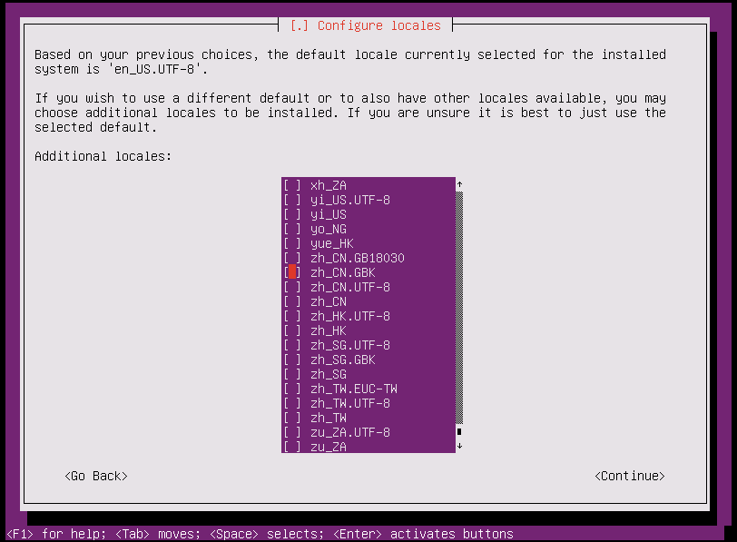

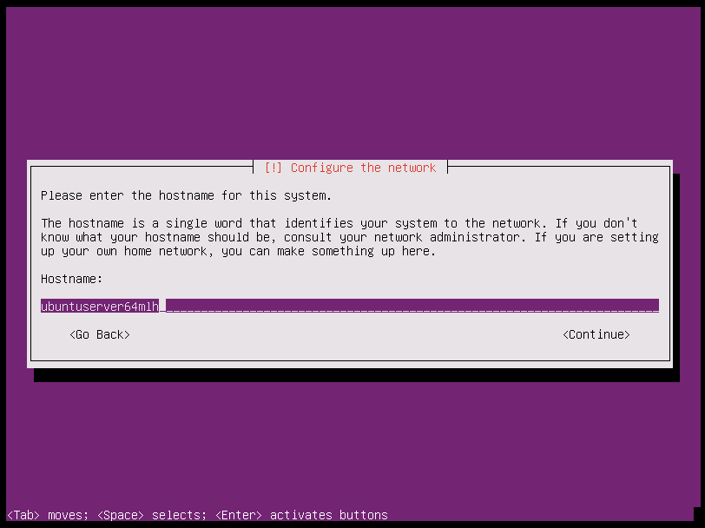

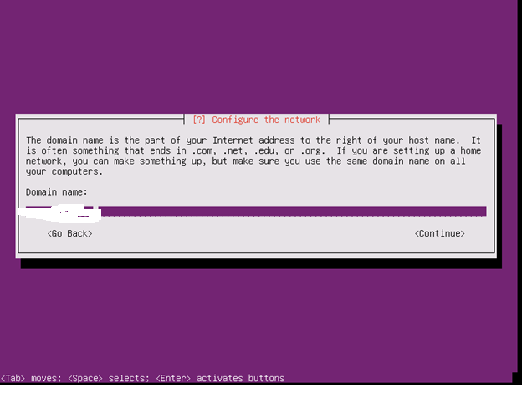

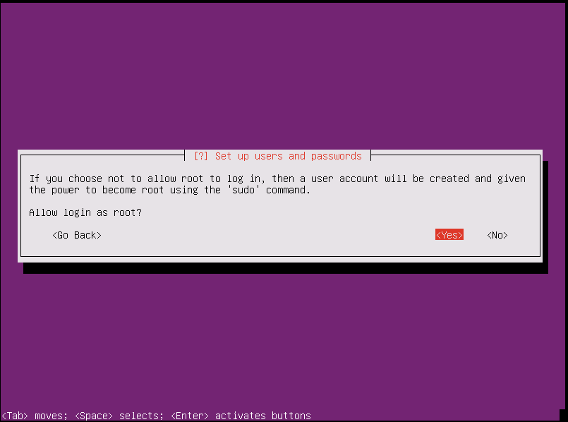

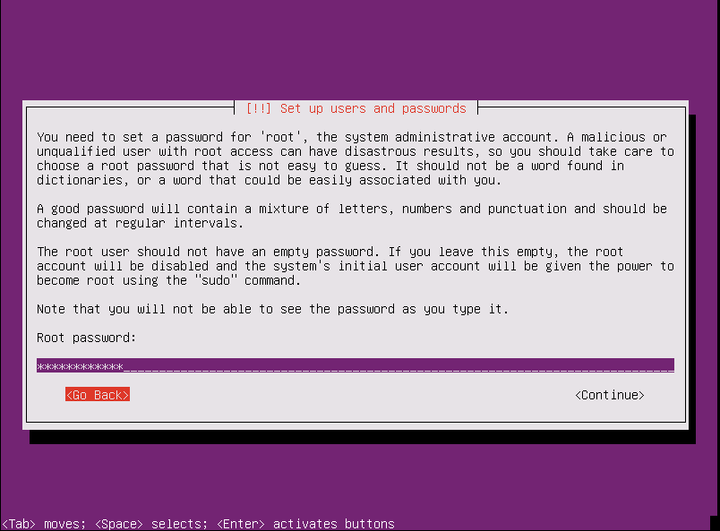

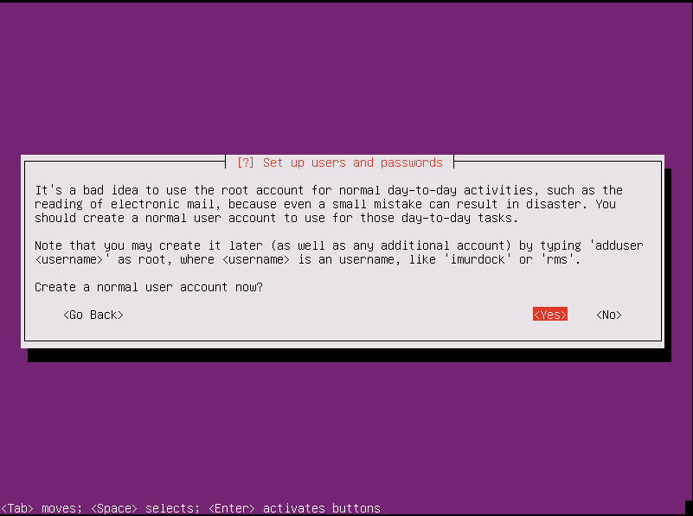

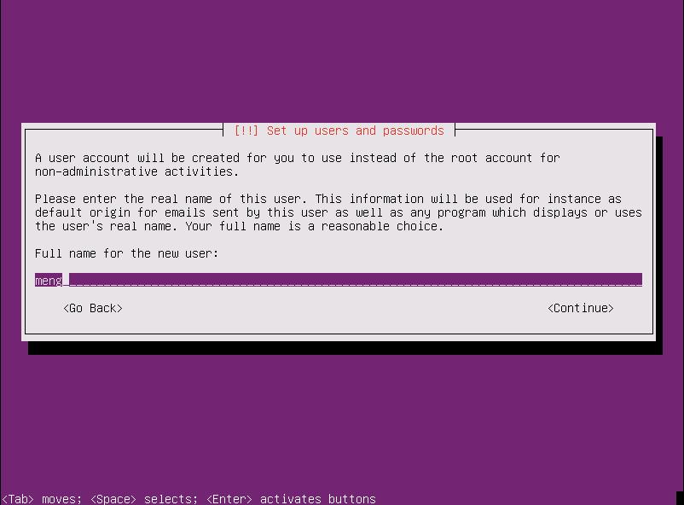

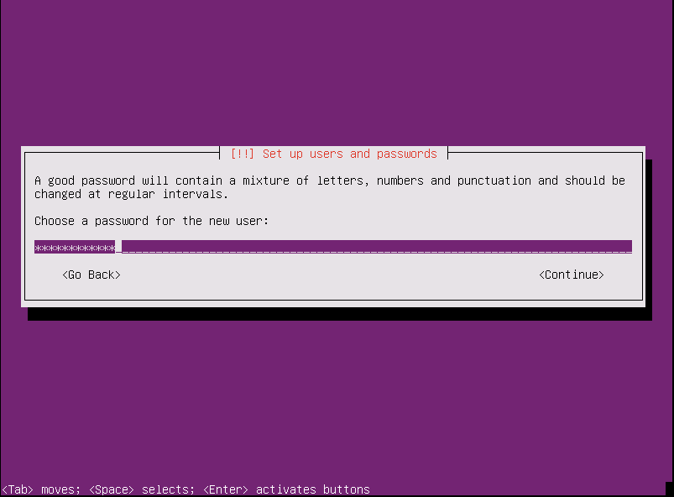

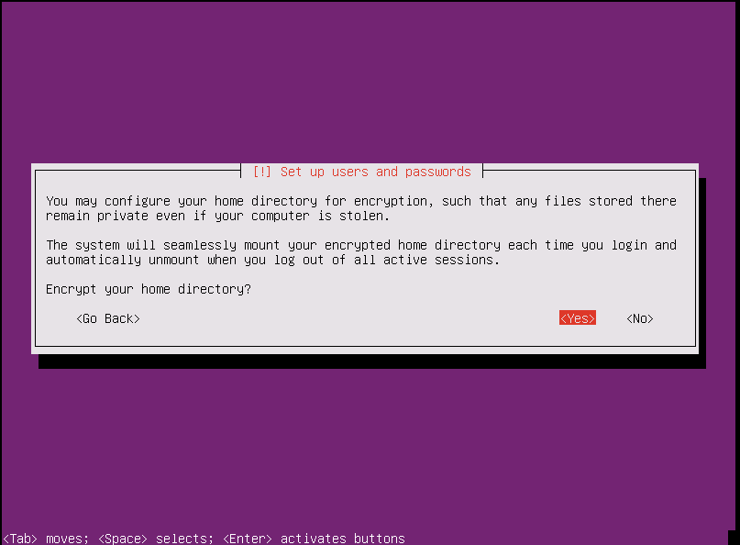

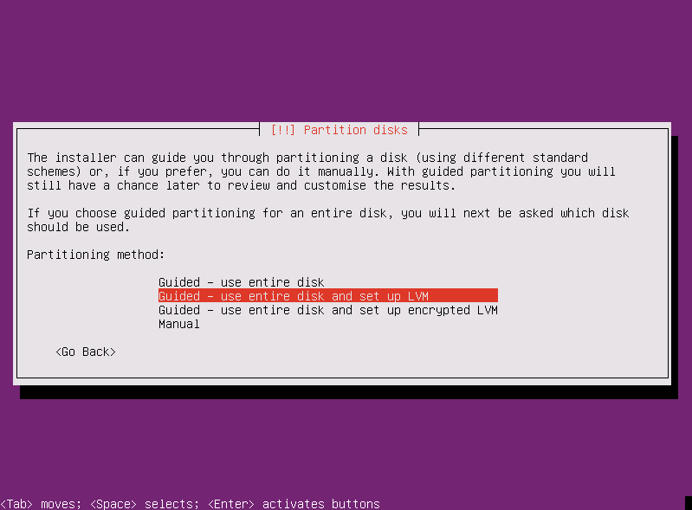

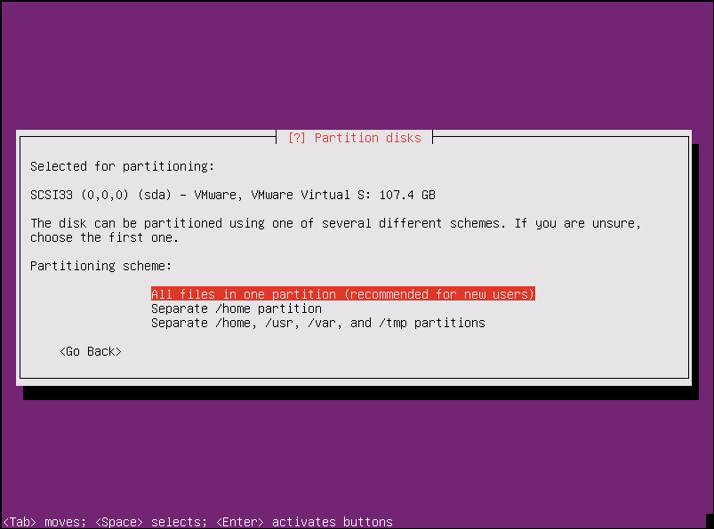

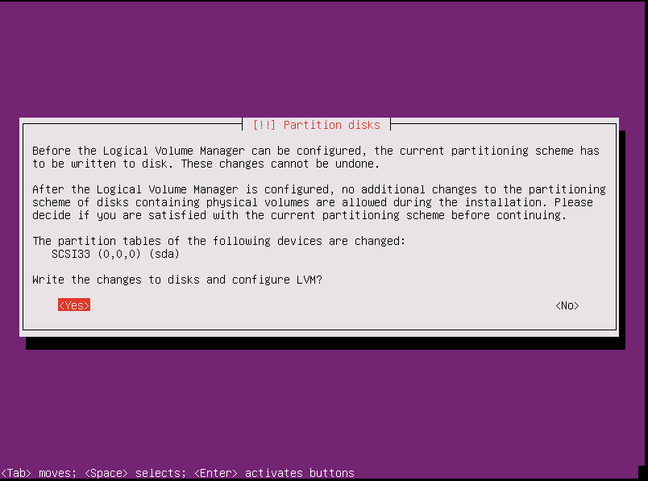

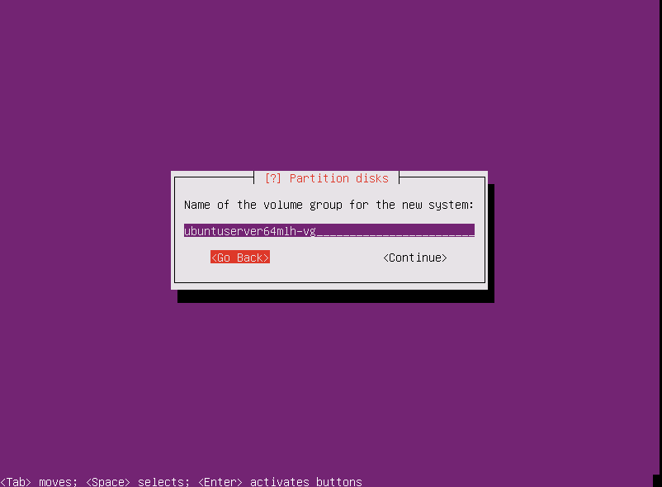

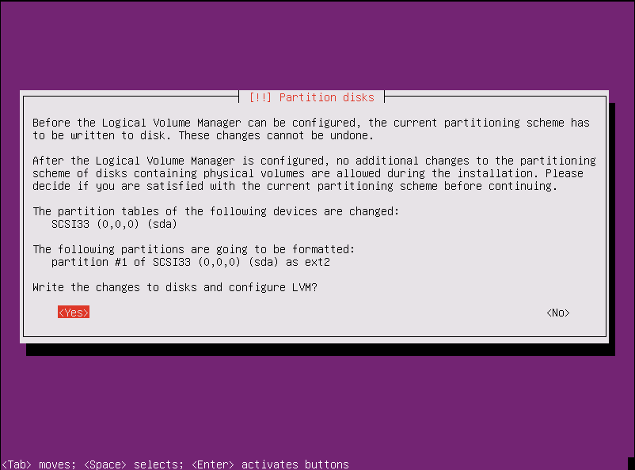

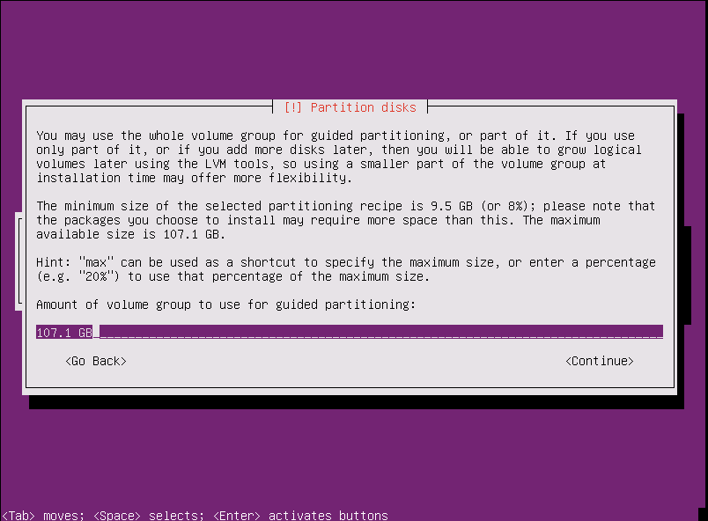

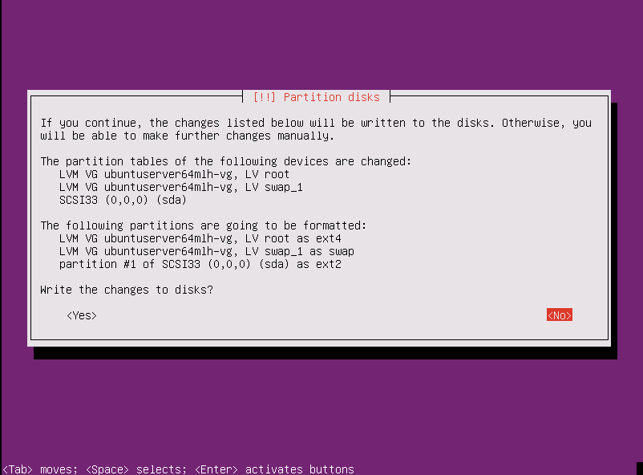

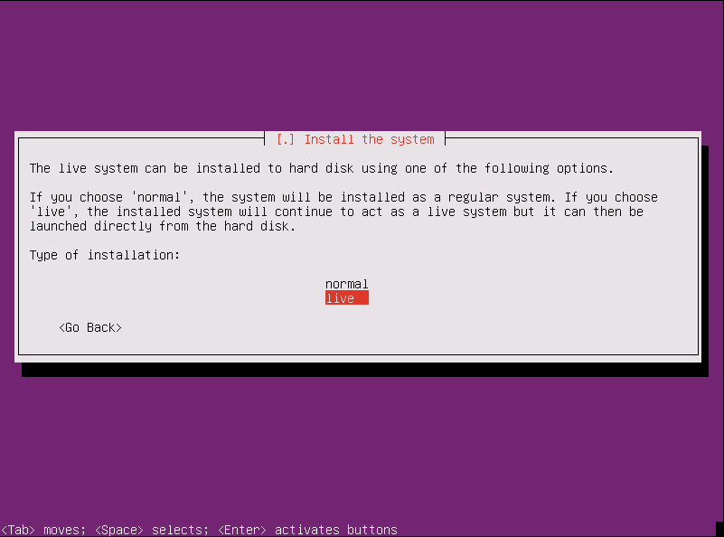

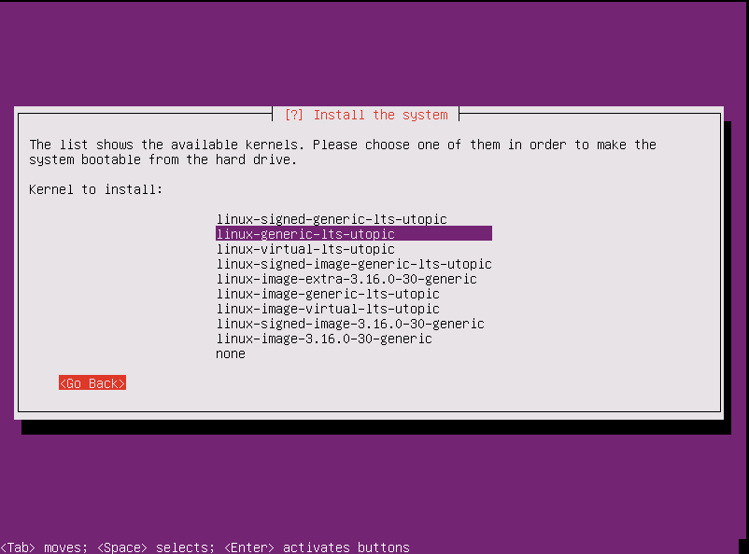

**第一次还出错了，说选择的server不能安装，重试了下，又可以了，本来想换virtual版本的**

**What is the advantage of a signed kernel?**

It is a security thing but there is no performance benefit four your system.

New Hardware will have secure boot. The problem is, that this hardware won't boot an OS that is not signed. The hardware is checking the software at startup if it is signed. If not, the hardware will prevent the software from booting.

This is a security thing, because it will prevent i.e. malware to start on your hardware.

There was a lot of discussion about this feature because a open source OS must get signed to run on future computers and that must be paid. And this is not the Open Source way.

Short explanation, but there is a lot of stuff on the web about it.

**What's the difference between the three linux-image variants in Ubuntu?**

The **linux-image-server** package is a meta package that will install the latest Server kernel version, while the **linux-image-generic** package is a meta package for the latest Desktop kernel version. The server guide includes some details on the changes made in the Server kernel.

**linux-image-server** is used for both architectures x86 and amd64.

Which one you should use will depend on the type of system you have. If you have a 64 bit processor you can use the amd64 architecture, or the x86 architecture. However, if your processor is 32 bit you can only use the x86 kernel.

**Virtual kernel:**

The difference between the Virtual and Server kernels is that the Virtual kernel is intended to be utilized inside a virtual machine. The virtual kernel only includes the necessary drivers to run inside popular virtualization technologies such as KVM, Xen, and VMWare. The server kernel in contrast contains the necessary drivers to work with a wide range of hardware, and should be installed directly on host systems. Other than that, all other options are identical between the server and the virtual kernel.

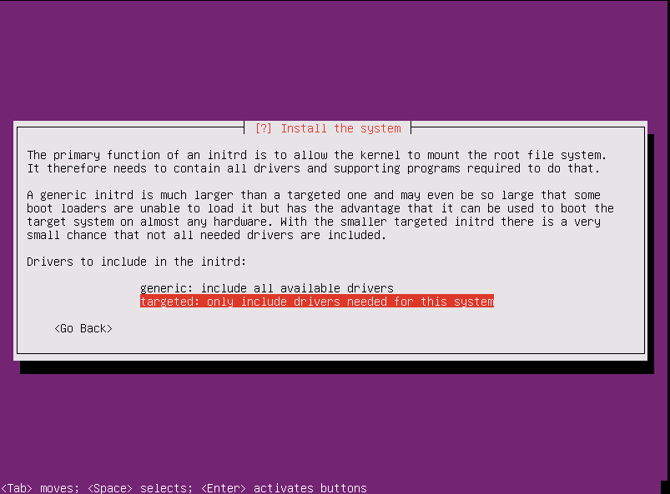

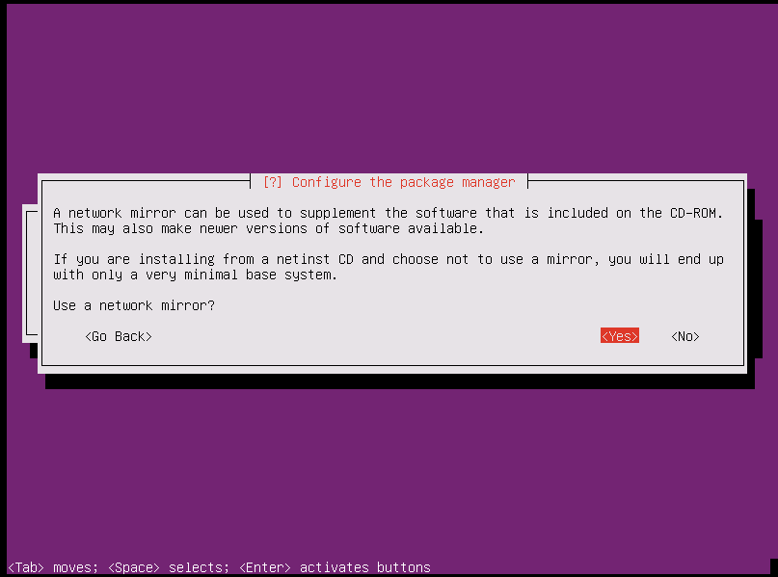

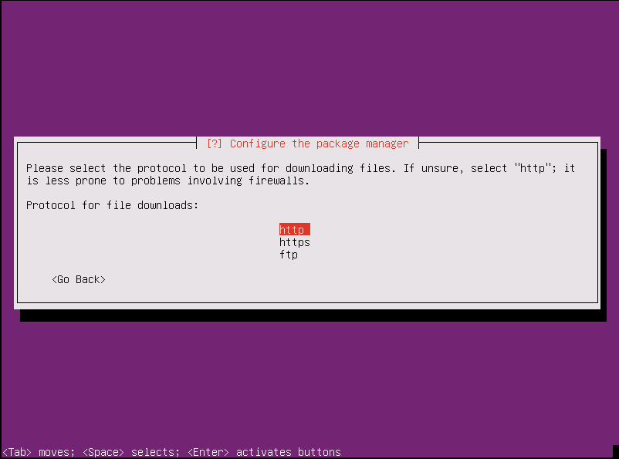

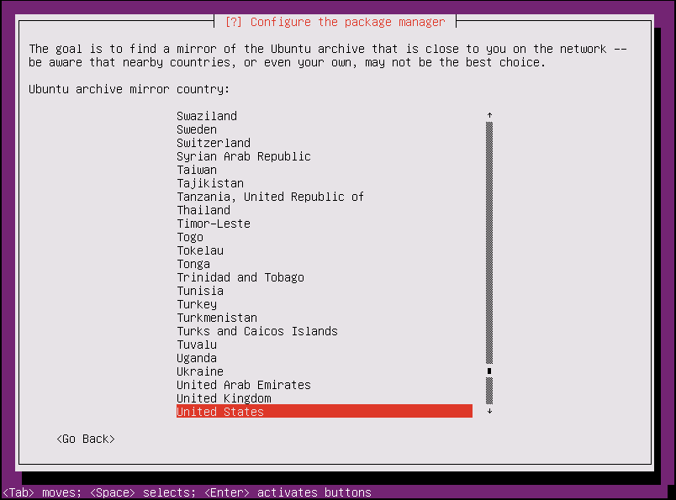

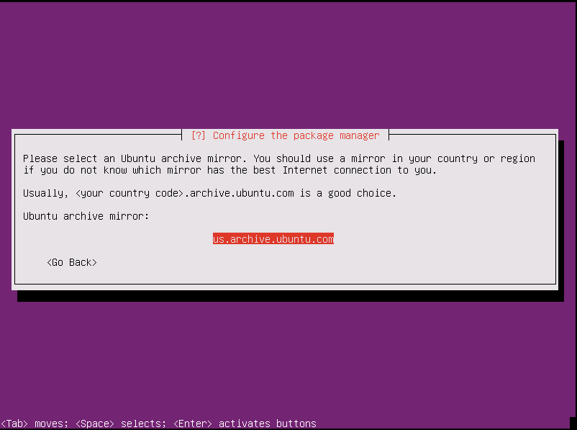

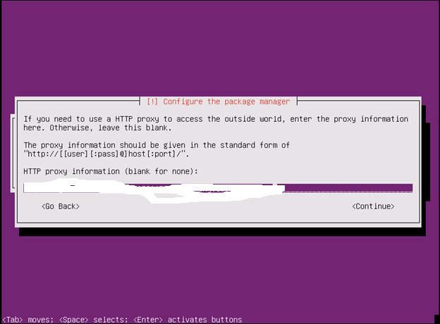

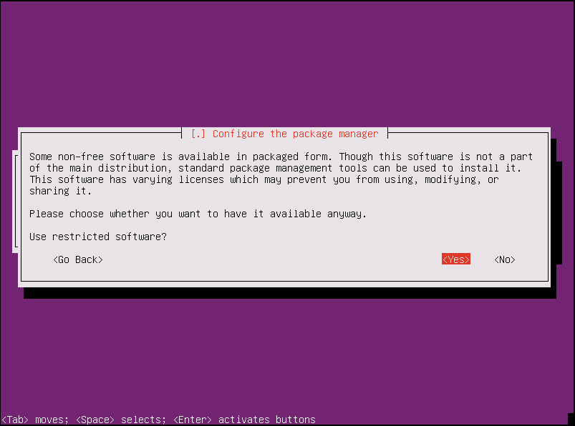

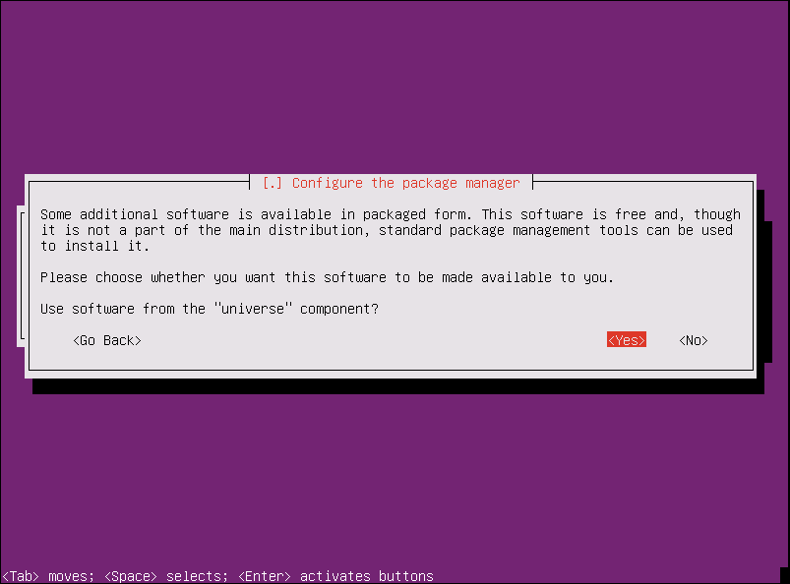

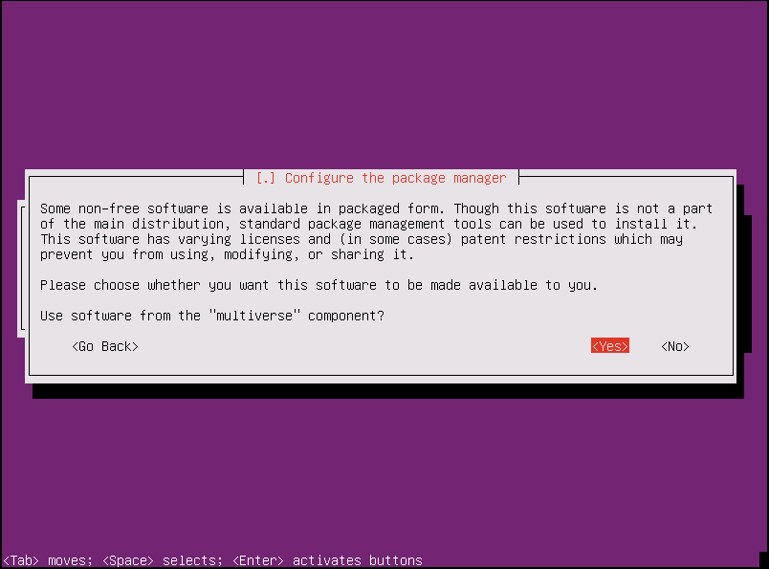

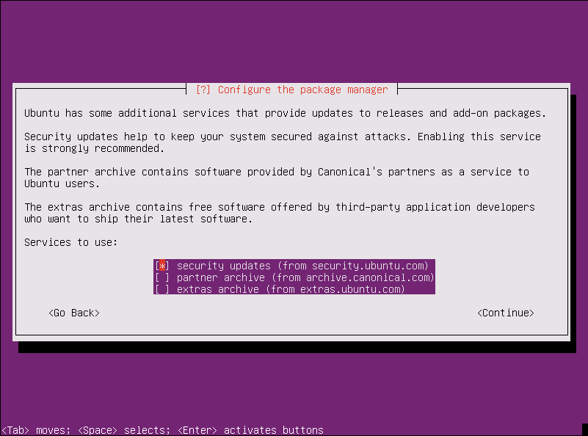

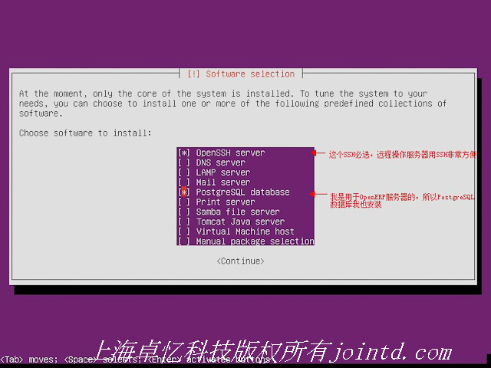

选择软件的时候我按了esc键，然后系统就自动开始装了，不知道到底装了啥

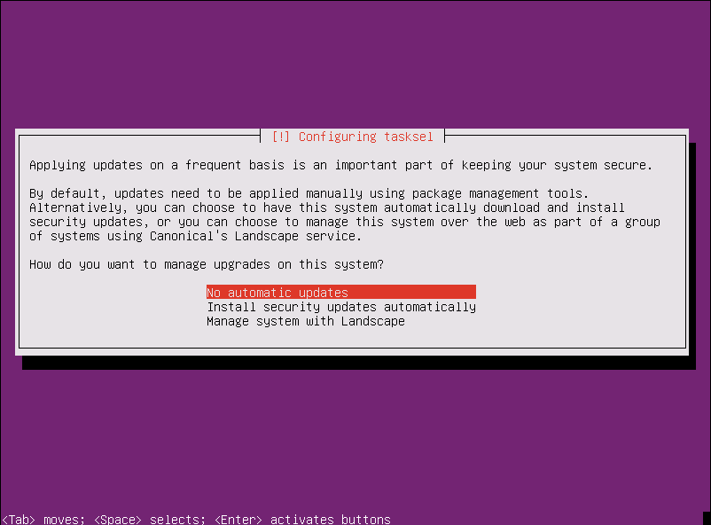

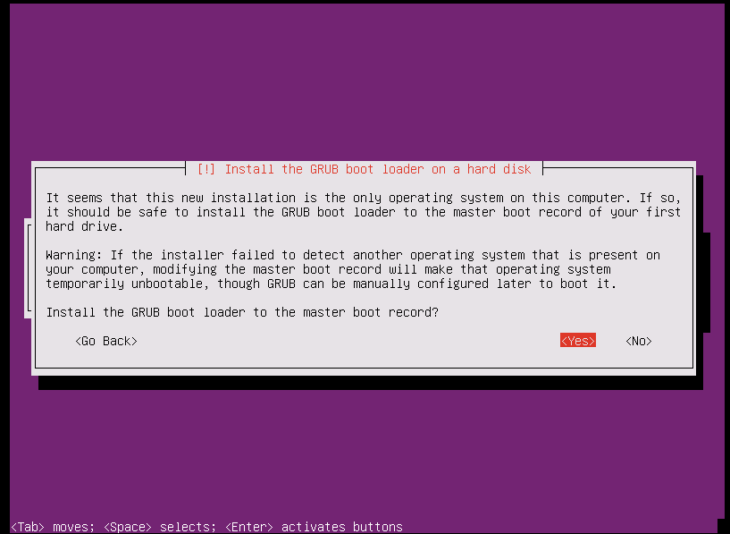

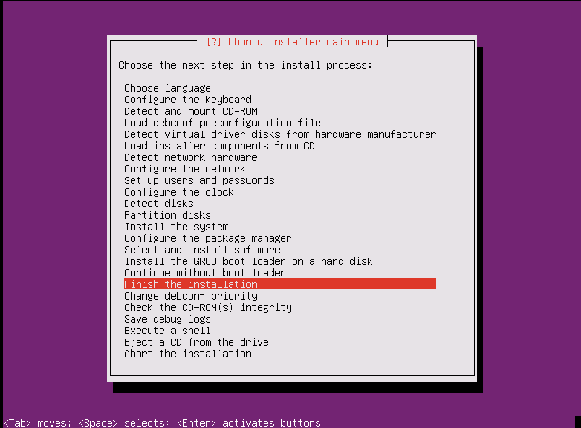

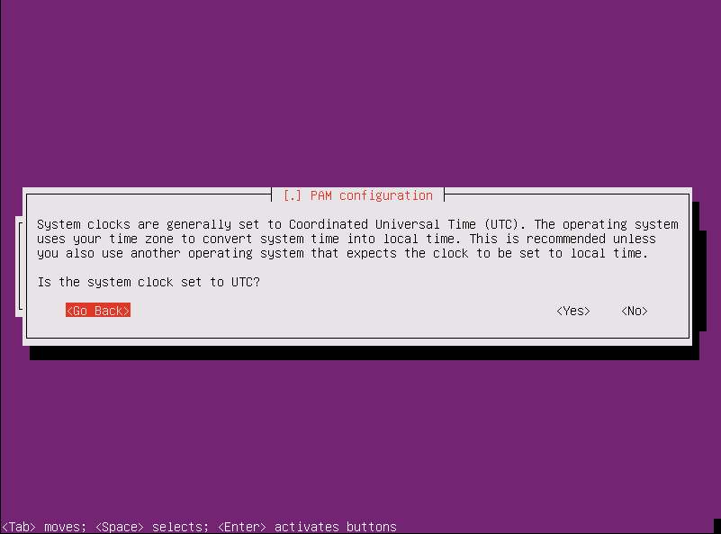

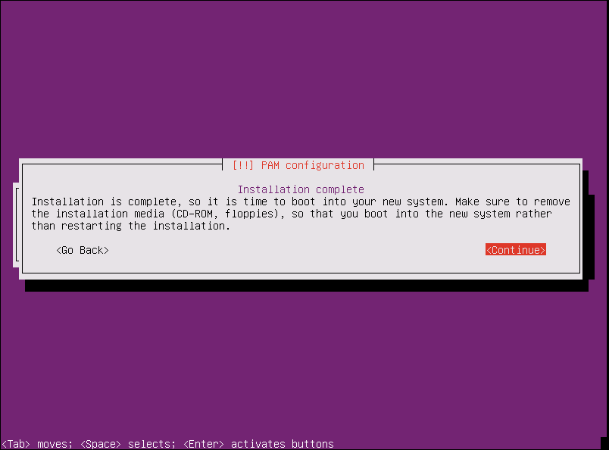

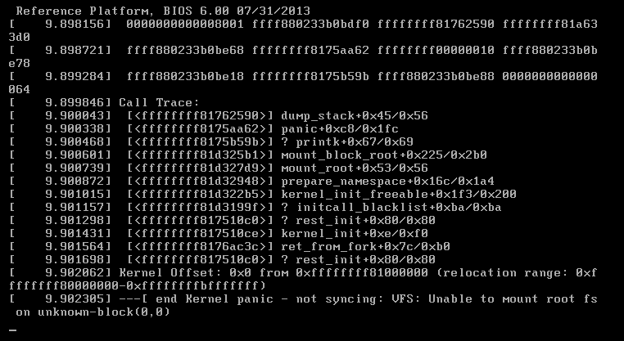

# 第二次

选normal模式

选linux-virtual-lts-utopic 内核，

# 第三次

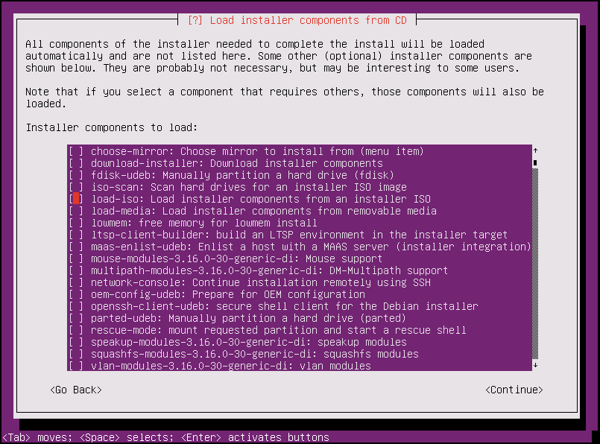

选择默认的linux kernel， 第二项

然后选择安装所有的drivers， 而不是仅仅针对target system

这次至少安装系统的时候没有出错了

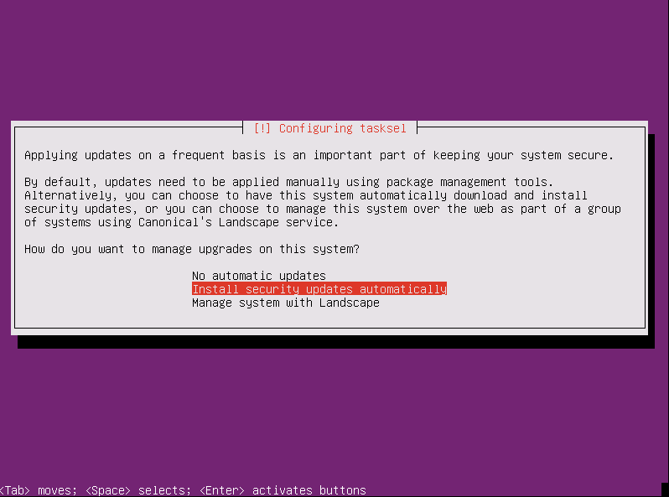

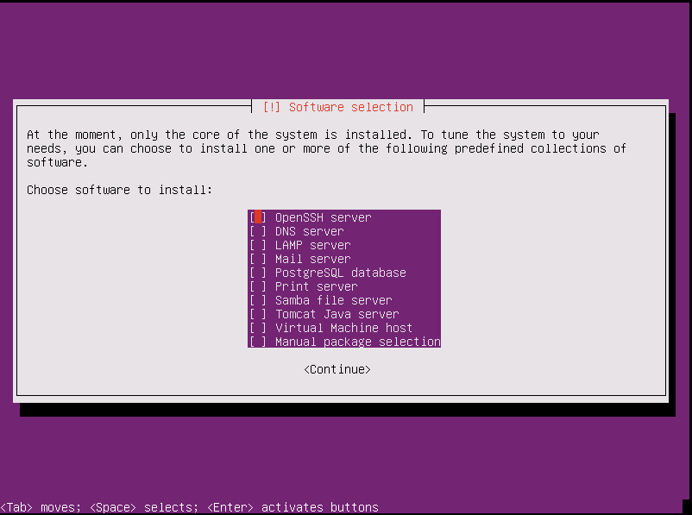

Open SSH Server 是用来允许客户端连接的，默认都装上